WebBrick Development Kit


Quick Start Guide

Andy Harris, January 2005

What you’ve got

In the box you have a WebBrick, Power Supply and CD.

The CD contains Python2.3 and a number of test programs as well as some PHP libraries along with the full user manual.

The WebBrick default IP address is 10.100.100.100 with a 255.0.0.0 subnet mask. DHCP is enabled by default so the WebBrick may acquire an address from a DHCP server.

Getting Started

You can test some basic operations of the WebBrick without connecting it to a network.

After power-up the WebBrick takes about 5 seconds to become operational. The default initial program is set such that the ‘Triggers’ will toggle the digital outputs and the rotary encoder will set the output of Analogue channel 0.

The ‘Triggers’ are connected to momentary action toggle switches. On each operation you should see the corresponding output change state.

Connect the WebBrick to your network and establish if it is using a DHCP served address or its default 10.100.100.100. Open a web browser to the IP address and you should see a page that looks like:

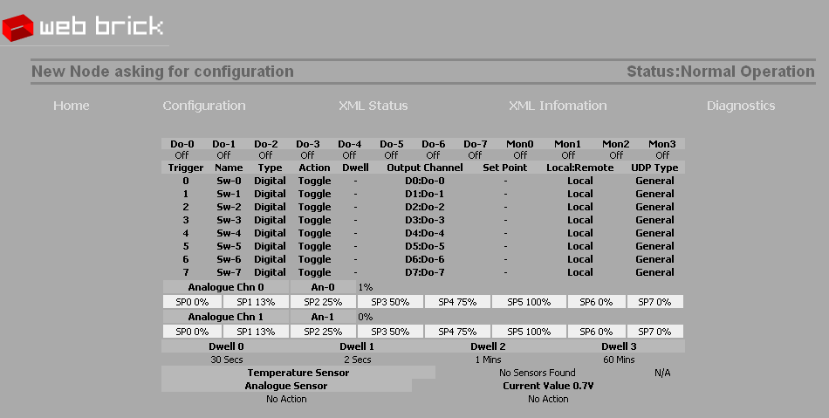

This shows that the Webrick is a new node and that there is no temperature sensor attached.

Now operate the first monitor toggle switch Monitor 0. Refresh the page by clicking on ‘Home’. Your page should now look like:

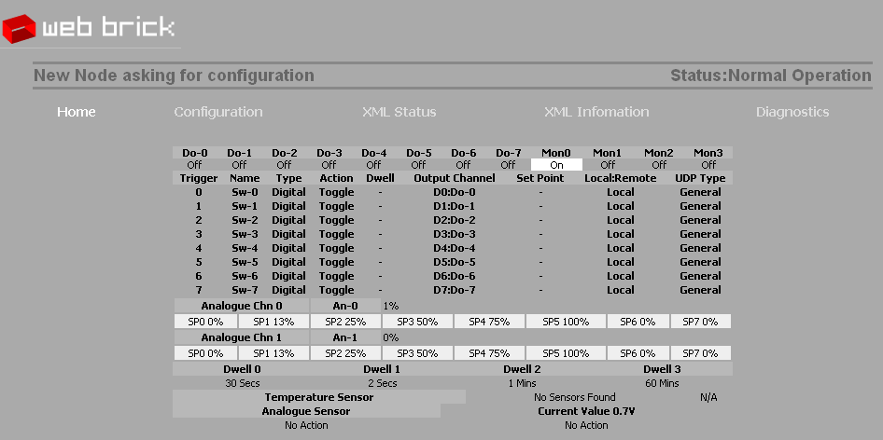

You can see that Monitor 0 is set to on. Now turn the rotary encoder clockwise for 16 or so clicks. You should see that the Analogue 0 LED begins to light. If you refresh the page again you should see something like this:

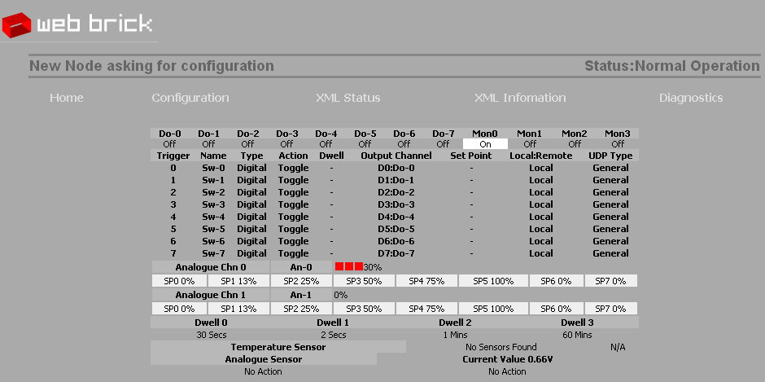

This confirms the setting of the Analogue Output 0 (in the above example 30%).

Now set the analogue input to a new position and refresh the page. You should see a new value for Analogue sensor:

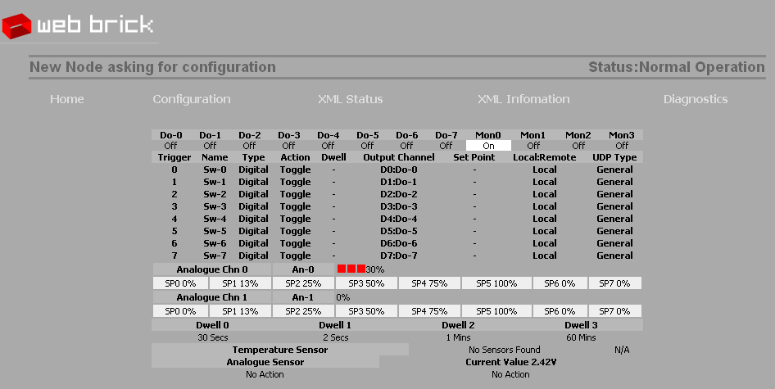

If you ‘mouse over’ the trigger sections you’ll see that the web page will tell you what would happen if you were to click on that trigger:

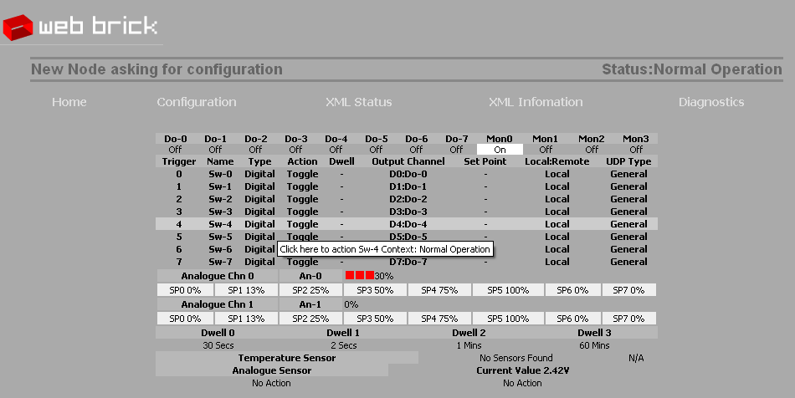

To action the Analogue channel click on the various Set Points that are marked [SPn].

You can see the XML status of the WebBrick by clicking on the [XML Status] link. The page you’ll see depends on your browser, but typically it will look like:

<webbrick>
<UDPStatus>1</UDPStatus>
<DigOutStatus>0</DigOutStatus>
<MonStatus>1</MonStatus>
<Context>1</Context>
<OWBus>0</OWBus>
<OWRes>255</OWRes>
- <AO>
<Value>304</Value>
</AO>
- <AO>
<Value>0</Value>
</AO>
<AI>496</AI>
</webbrick>

Now we can start to configure the WebBrick to change its behaviour, click on the [Configuration] link to see this page:

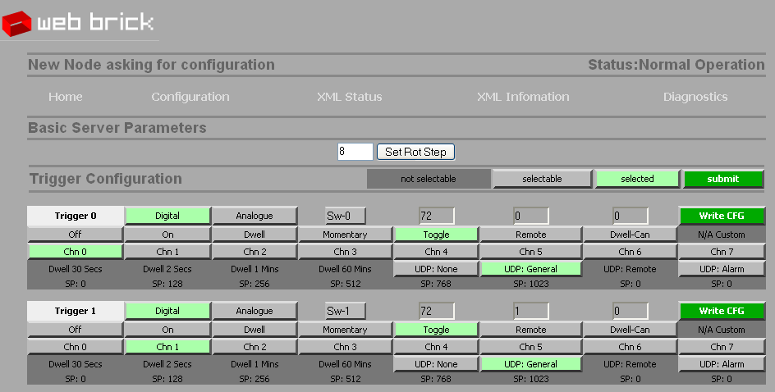

We can use this page to set the behaviour of ‘Trigger 0’ to create a 30 second ‘Dwell’ on digital output 0. Click on the buttons to select this then click the [WriteCFG] button. You configure one trigger at a time:

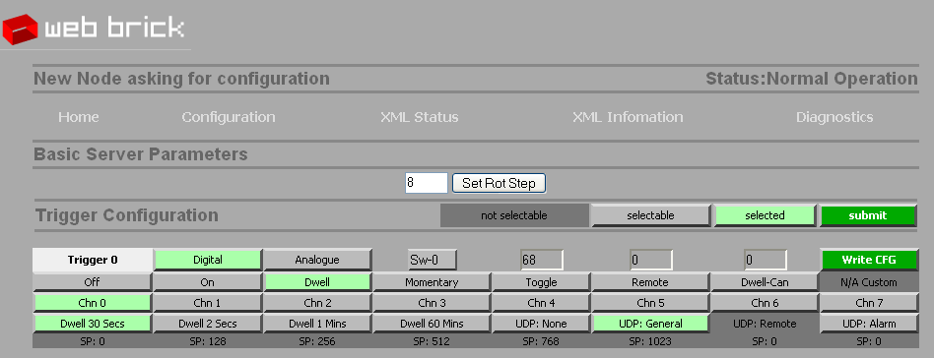

Now, click on the [Home] link and you should see that the configuration of Trigger 0 has changed:

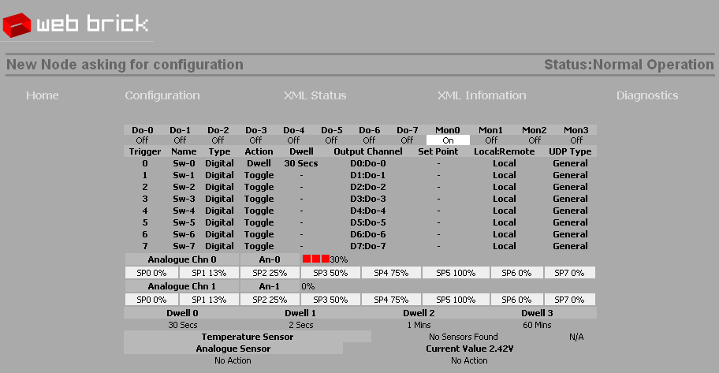

By Trigger 0 you can see that the ‘Action’ has changed to Dwell and the ‘Dwell’ is now 30 seconds. Either click on the Trigger or operate the momentary toggle switch to observe that the Digital Output 0 stays on for 30 seconds. Note that if you operate the switch within the 30 seconds, the output will remain high for a further 30 seconds from that point.

Let’s now go back to [Configuration] and use a ‘Dwell-Cancel’ action for one minute. The configuration page will look like:

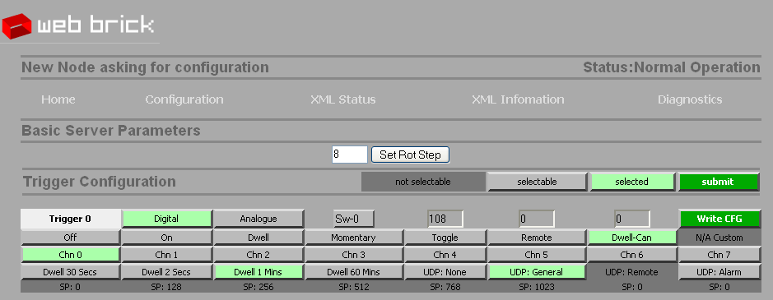

Now check the behaviour of Trigger 0. This time you’ll find that if you action the Trigger and do nothing else, Digital Output 0 will go high for one minute. If you action Trigger 0 whilst Digital Output 0 is high, the ‘Dwell’ will be cancelled and Digital Output 0 will go low. This kind of configuration is very useful for heated floors in bathrooms, where people may or may not forget to switch the floor off, i.e. it can be switched off, but if it is left it will eventually switch off anyway.

The configuration page shows what other options are available, and will configure itself accordingly. For example on a WebBrick there are two analogue outputs and 8 digital outputs. If you select an analogue action within the configuration channel you’ll see that only two channel buttons become available.

Setting the basic WebBrick parameters

In this section we deal with setting the IP address, the node name and the node number. These cannot be performed without logging into the WebBrick. The default password for a WebBrick is ‘web238’.

To log in, click on the Diagnostics link. You’ll see a page like:

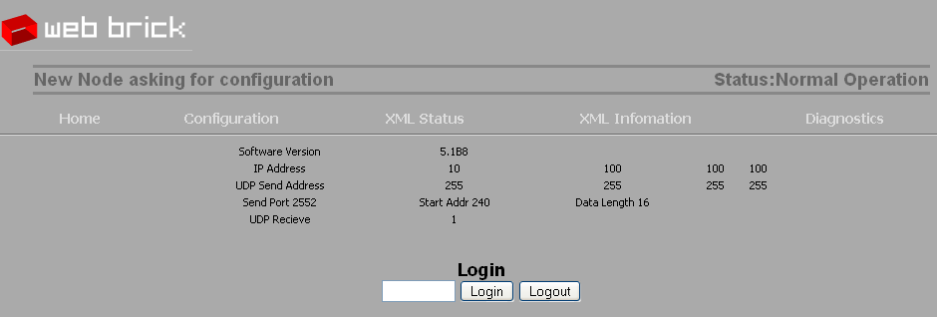

Login and this page will change to look like:

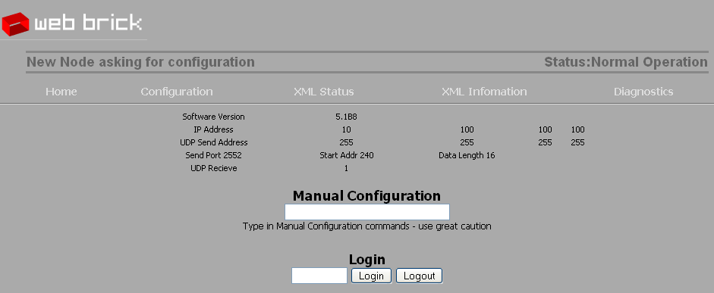

Setting the IP address

In the manual configuration, you can enter a new IP address. Be aware that the WebBrick will immediately use this new address. The command structure is:

IAn;n;n;n;:

Where each ‘n’ is part of the IP address. Note that the dot is replaced by a semicolon.

Setting the Node Name and Node Number

After logging in, the details in the [Configuration] link will change to look like:

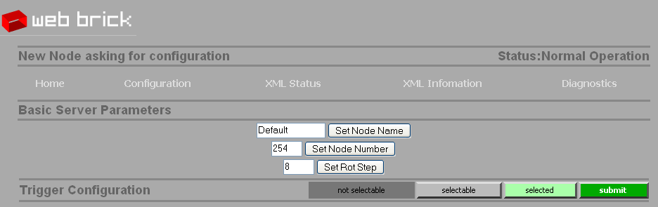

Here you can set the Node Name (11 characters) and Node Number (1-253). Note that 254 is a special case Node Number in that this value means ‘I am new’; The WebBrick will still work, but every 20 seconds it will be sending out a UDP packet saying “I’m new and I need configuration”

Getting started with the PHP and Python programming interfaces

In architecture terms we’ve provided three elements:

XML configured panels for PHP pages
A PHP library of WebBrick Functions
A Python library of WebBrick functions

The easiest way to get started is to configure a XML file that renders your view of your WebBrick, you’ll be getting a result that looks a bit like:

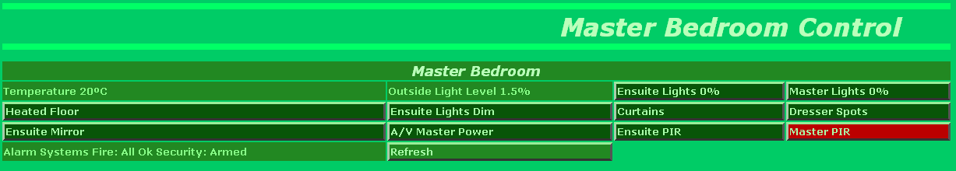

To include the PHP libraries in your file use these include statements:

<?
include("../phplib/weblib.php");
include("../phplib/statuslib.php");
?>

“weblib.php” is the library that contains the WebBrick functions. “statuslib.php” is the library that contains the function that render the panel.

The active section of the PHP file looks like:

<? processCmd(); ?>
<? populateStatus('bedroom.xml','panel'); ?>

The processCmd() call will process any command that is found in the URL string. The populateStatus(..) call reads through the supplied XML file and creates the panel as shown.

The start of XML file looks like:

<?xml version="1.0"?>
<status>

<item>
<Comment>This configures the overall feel of the panel</Comment>
<Title>Master Bedroom</Title>
<Type>Header</Type>
<cols>4</cols>
</item>

<item>
<Title>Temperature</Title>
<Type>Temp</Type>
<IP>10.100.100.100</IP>
</item>

The definition of a ‘switch’ or action to a trigger looks like:

<item>
<Title>Heated Floor</Title>
<Type>Switch</Type>
<IP>10.100.100.100</IP>
<Chan>0</Chan>
<Trig>trig;10.100.100.100;0</Trig>
</item>

The important entries here are <Title> this renders the name of the button; <Type>, Switch means that the button has a momentary switch action; <IP> Is the IP address of the WebBrick to read the status from, and <Chan> is the output channel on that WebBrick; This state is used to render the colour of the button.

<Trig> is the actual command that gets passed through the URL back to the host. This is important because the <Trig> may not operate on the same WebBrick, or may issue a batch job that indirectly affects the WebBrick and channel that is rendered.

Note that in this case it is the simple example where the output channel displayed is directly related to the trigger that operates it.

Simple Python Program

Here’s a very simple Python program that set the state of a Digital Output channel to “ON”:

import wb
brick = wb.wb()
result = brick.DigOut("10.100.100.100","5","N")

The “import wb” line imports the WebBrick Python library which must be either in the same directory as the running program or in the Python library directory tree.

“brick – wb.wb()” creates an instance of the WebBrick class called “brick”.

“result = brick.DigOut(…)” issues the command to the WebBrick. Note that the “5” is the Digital Output channel and the “N” is the command (in this case ON). See the WebBrick user manual for full details.

Further support and resources

See the O2M8 webpage at:

http://www.o2m8.com

Here you’ll find articles and sections on WebBrick programming and installations.

You can email the author of this guide at andy (at) o2m8 (dot) com.

